Megan Beyer
Extended Care Project
USJ Dietetic Internship
October 27th, 2016

Introduction:
The patient is an 84-year-old male who was admitted on August 31st, 2016 to the extended care facility. Prior to admission to the long term care facility, past medical history of thrombocytopenia, Barretts esophagus without dysplasia, atrial fibrillation, chronic duodenal ulcer without hemorrhage or perforation, atherosclerosis, heart disease, essential hypertension, diverticulosis of large intestine with perforation, chronic kidney disease (stage 3) and GOUT. Patient presented to emergency department for gastrointestinal bleed evidenced by two incidence of blood stool with admitting diagnosis of pancreatitis. Patient transferred to long term care for general rehabilitation related to weakness. Diet upon admission as no added salt. Patient is alert and able to self-feed, has all of his teeth. The patient is concerned about the amount of weight he lost and is looking forward to his appetite returning and going home.

Nutrition Assessment:
Anthropometric: Patient’s current height is 70 inches. The admission weight on 8/31/16 was 163 pounds. Patient reported significant weight loss of 58 pounds in the last six months, 26% weight loss. The patient’s current BMI is 23.3 kg/m², indicating that he is normal weight. The patient is 78% of their UBW of 208 pounds. The patient is 97% of their IBW of 166 pounds. The patient is at 100% of goal weight of 175 pounds.

Biochemical Data, Medical Tests and Procedures:
The patient had lab tests collected prior to admission on 8/31/16 indicated in Table 1. The most relevant lab tests resulted with creatinine 1.4 (L), albumin 2.6 (L), hemoglobin 9.7 (L), hematocrit 31.2 (L). The patient’s creatinine was slightly elevated because of the blood in the GI tract and general dehydration (Nelms, 2016, p. 61). The albumin levels were low due to inflammation of chronic disease resulting in long term malnutrition and inadequate caloric intake (Nelms, 2016, p. 58) Both hemoglobin and hematocrit are low due to loss of blood status post GI bleed and dehydration (Nelms, 2016 p. 59). Follow up labs were completed on 9/13/16 indicating his hemoglobin is improving.

Client History: Resident has a history of chronic unspecified gastric ulcer with hemorrhage, a history of Barret’s esophagus without dysplasia, atrial fibrillation, atherosclerosis, essential hypertension, stage three kidney disease and GOUT. Per admit documentation patient admitted for GI bleed thought to be pancreatitis, found to be warfarin induced coagulopathy.

Medications: Medications for the resident include Colace as a laxative, Protonix for his reflux, Carafate to protect the lining of the stomach, Zyloprim to treat GOUT, and Magonate as an anti-acid. Colace is a stool softener that should be taken with a diet that is higher fiber and 1500-2000 milliliters of fluid per day (Pronsky, 2015, p. 117). Protonix is a type of proton pump inhibitor for anti-GERD, and the patient should avoid taking gingko or Saint John’s Wart (Pronsky, 2015, p. 280). Carafate is an anti-ulcer medication, patients should have a bland diet that should be taken separately from anti-acid (Pronsky, 2015, p. 312). Zyloprim is an anti-GOUT agent, patient should drink 2.5-3 liters of fluid per day to produce 2 liters of urine output along with avoiding large doses of vitamin C (Pronsky, 2015, p. 27). Magonate is a mineral supplement that acts as an anti-acid that should be taken after meals. It is recommended that it is not take with high fiber foods, high oxalate food or high phytate foods (including whole grains, rice, beans, and nuts) (Pronsky, 2015, p. 210). The patient did not have any nutrition supplements on order.

Nutrition Focused Physical Exam: The patient’s skin was good, it was clean, dry and intact with no rash. The patient was slightly dehydrated from episodes of diarrhea. Cognition was good. Patients skin is intact and has redness at the coccyx 5 by 6 mL. The patient had no edema. The patient wore glasses, and was slightly hard of hearing. The patient had all of his teeth and when admitted he had trouble chewing tough meats and needed tender meats, though report no issue with swallowing. The patient was mobile with the use of a walker, and physical therapy suggested the use of a cane as well. Resident has a score of 17 on the Braden scale indicating low risk for pressure ulcers. The patient was evaluated using the Mini Nutritional Assessment tool. When filling in the corresponding information the patient received a score of 9 which indicated the patient was at risk for malnutrition (see below for rating).
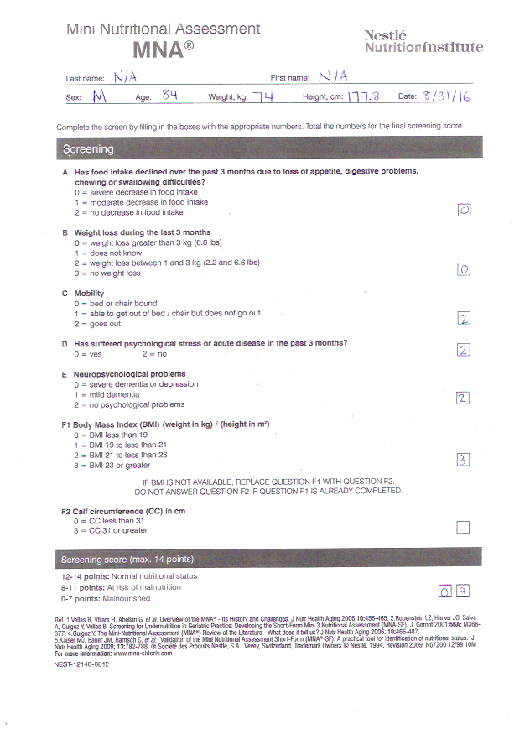

Diet History: Patient lives with wife who eats strictly organic and a very balance diet. The wife cooks at home and follows a low sodium diet, usually patient has a very good appetite and enjoyed large portions. Typical for breakfast patient would eat Uncle Sam cereal with whole milk or cream of wheat. For lunch the patient would have half a sandwich and homemade soup. For dinner the patient would typically have a large Italian dinner with pasta, tomato sauce, vegetables and a source of protein such as beef or sausage. Directly prior to admission patient appetite decreased significantly and patient consumed one cup of white meat (chicken, turkey, seabass) and homemade broth liquefied into a high protein drink and two cups of fruit smoothie per day due to wife and daughter’s concern of nutritional needs of patient. Patient stated he was sick of eating chicken. Patient drank one ensure supplement at home, but felt it was too filling. Upon admission to long term care facility patient did not report any specific dislikes for food except oatmeal. Patient denied any nausea, vomiting, diarrhea or constipation. Patient is currently at risk for dehydration related to poor oral intake of fluids and episodes of bloody diarrhea. Patient has good oral intake, consumed 76-100% of his meals per the nursing meals tracker. Fluid intake documented to meet goal daily 50% of the time during admission.

Comparative Standards: Calorie requirements calculated for the resident are 2220 calories based on IBW, fluid requirements are 1480 milliliters and protein requirements are 74-88 grams. Calories needs were calculated by using a 25 calorie/kg and 30 calorie/kg to yield a range. The fluid needs were calculated by using 20 milliliter/kg. The protein needs were calculated using 1.0 gram/kg.

Nutrition Diagnosis:
Unintentional weight loss (NC-3.2) related to poor appetite as evidence by self-reported poor P.O. intake and 58# weight (26%) loss in 6 months.

Nutrition Intervention:
Resident Involvement in Meal Planning: In this specific long-term care facility, they have a liberalized dining program. The patient is able to select items offered on paper menus or communicate with diet clerk their preferences for the following meals. Dietitian spoke with patient to select items on menu that were low residue, bland and soft. Discussed avoiding garlic, spicy, chocolate and orange juice to avoid symptoms of reflux per GERD. The current diet order was bland/low residue and patient will continue diet upon return home. Due to the spouse managing the meals at home, she was included in the nutrition education that occurred in the patient’s room. Both patient and spouse asked relevant questions on diet education for bland diet.

Diet Liberalization: When the patient was admitted he was on a no added salt diet soft diet that included moist meats due to his difficulty chewing tough protein and vegetables. For extra calories the dietitian suggested adding vanilla ice cream to the lunch and dinner tray. This ice cream provided 60 calories, 2 grams of protein in 3 fluid ounce, which the patient tolerated the ice-cream well. The patient’s chewing issue resolved on its own after reintroducing solid foods into the diet. The patient did not have difficulty swallowing, therefore a Speech Language Pathologist did not need to perform a bedside swallow evaluation and he was on upgraded to a regular consistency diet per patient request. Patient was then on a Heart healthy, low residue diet. This diet was a sodium restricted diet of 2000 mg per day, and would not receive salt packets on his tray upon delivery of his meal. Additionally, for the low residue portion of the diet, the patient received no nuts, seeds or corn. Patient stated he enjoyed the food and after many visits with patients daily his appetite returned to normal.
Progression of Diet Order
Date | Diet | Notes | Rational
8/31/16 | No Added Salt, Soft consistency | Meats softened with gravies and sauces | Difficulty chewing
9/9/16 | Heart healthy, low residue, regular consistency | No nuts seeds or corn | Chewing returned to normal

Medical Food Supplement: Patient was first given Mighty Shakes three times a day in-between meals. The Mighty Shakes are 200 calories, and 6 grams of protein in 4 fluid ounces. The dietitian then suggested patient to drink 2 8-ounce Boost Plus per day to increase calories for the patient. Boost Plus Vanilla has 360 calories, 14 grams of protein, and 22 grams of sugar in 8 fluid ounces. Patient denied Boost Plus because of the high sugar content and found alternative product to meet his needs. Patient’s wife purchased Ensure Active and brought to the long term care facility. Ensure Active Vanilla has 160 calories, 16 grams of protein, and 4 grams of sugar in 8 fluid ounces. Patient drank vanilla flavored to help minimize GERD symptoms. Patient’s wife brought him 2- 8 ounces Ensure Active during the duration of his stay. Patient tolerated Ensure Active well and enjoyed drinking them twice daily.
Progression of Nutrition Supplement Order
Date | Product | Frequency | Nutrient Needs
8/31/16 | Mighty Shakes | Three times daily | 200 calories, and 6 grams of protein in 4 fluid ounces
9/10/16 | Ensure Enlive | Twice daily | 160 calories, 16 grams of protein, in 8 fluid ounces
9/15/16  (Patient Discharged) | Ensure Enlive | Once daily | 160 calories, 16 grams of protein, in 8 fluid ounces

Nutrition Monitoring/ Evaluation:
Anthropometric Measurements: The resident was ordered for weekly weights after initial admission to long term care facility. Patient was weighed on 9/14/16 with weight of 176 pounds with shoes, button down, and pants. Patient had gained 13 pounds since admission to long term care facility. Patient should remain within 5 pounds of current weight of 176 pounds over a 6-month period to stabilize weight.

Biochemical Data, Tests and Procedures: Lab data collected on 9/13 (Table 2). Hemoglobin has significantly increased since loss of blood due to GI bleed. No other lab data reported at this time. Patient hemoglobin levels should normalize within 14.6- 17.5 g/dL over a one-month period after returning home.

Client History: Since the admission on 8/31/16 no change in mental status, swallowing or chewing dysfunction. The patient’s cognition remained normal, and no pressure ulcers were noted. Patient will be discharge to be sent home who lives with wife and daughter attended patient care conference to address all needs of patient. Patient should remain on bland, low residue diet with regular consistency diet for one month eating three meals a day.

Food History: Previous to admit patient was not eating for two weeks due to early satiety and generalized weakness due to anemia. Meal intake for the patient’s first week of bland/ low residue diet indicated in Table 3. Per nurse recording of meals, patient is eating well. Per patient report prior to discharge appetite had returned to normal. Continue to monitor oral intake of patient and tolerance to Ensure prior to discharge. Patient should drink one Ensure Enlive Vanilla (160 calories, 16 grams of protein, in 8 fluid ounces) each day for one month.
Table 1: Lab Values on 9/6/16
Lab | Value | Reference Range | Level Indication
BUN | 21 | 8-23 mg/dL | Normal
Creatinine | 1.4 | 0.6–1.2 mg/dL | High
Phosphorus | 4.1 | 3.5-5.0 | Normal
Glucose | 86 | 70-99 mg/dL | Normal
Sodium | 143 | 135- 145 | Normal
Albumin | 2.6 | 3.5-5.0 gm/dL | Low
Hemoglobin | 9.7 | 14.6 – 17.5 g/dL | Low
Hematocrit | 31.2 | 41-51% | Low

Table 2: Labs Done on 9/13/16
Lab | Value | Normal Values | Level Indication
Hemoglobin | 11.7 | 14.6- 17.5 g/dL | Low

Table 3: PO Intake Report
 | Breakfast | Lunch | Dinner | Bedtime Snack
8/31/16 | ---- | ---- | 76-100% | 76-100%
9/1/16 | 76-100% | 76-100% | 76-100%
9/2/16 | 76-100% | 76-100% | 76-100%
9/3/16 | 76-100% | 76-100% | 76-100%
9/4/16 | 76-100% | 76-100% | 76-100%
9/5/16 | 76-100% | 76-100% | ----
9/6/16 | 76-100% | ----- | 76-100%
9/7/16 | 76-100% | ----- | 76-100%
9/8/16 | 76-100% | 26-50% | 76-100%
9/9/16 | 76-100% | 76-100% | 76-100%
9/10/16 | 76-100% | 76-100% | 76-100%
9/11/16 | 76-100% | 76-100% | 76-100%
9/12/16 | 76-100% | 76-100% | 76-100%
9/13/16 | 76-100% | 76-100% | 76-100%
9/14/16 | 76-100% | 76-100% | 76-100%

Table 4: Fluid Intake Report
8/31/16 | 360 mL
9/1/16 | 240 mL + 120 mL + 360 mL + 240 mL = 960 mL
9/2/16 | 120 mL + 120 mL + 120 mL + 240 mL + 240 mL +240 mL = 1080 mL
9/3/16 | 120 mL + 180 mL + 240 mL + 360 mL + 120 mL + 120 mL + 360 mL + 240 mL + 420 mL= 2160 mL
9/4/16 | 120 mL + 120 mL + 240 mL + 240 mL + 240 mL + 240 mL + 360 mL = 1560 mL
9/5/16 | 180 mL + 120 mL + 240 mL + 240 mL + 360 mL + 240 mL = 1380 mL
9/6/16 | 120 mL + 180 mL + 240 mL + 360 mL + 240 mL + 240 mL = 1380 mL
9/7/16 | 120 mL + 120 mL + 240 mL + 240 mL +540 mL + 240 mL = 1500 mL
9/8/16 | 240 mL + 360 mL + 360 mL + 480 mL + 240 mL + 240 mL + 120 mL = 2040 mL
9/9/16 | 420 mL + 180 mL + 240 mL + 180 mL + 120 mL + 240 mL = 1380 mL
9/10/16 | 480 mL + 240 mL + 360 mL + 240 mL + 120 mL + 120 mL + 120 mL = 1680 mL
9/11/16 | 360 mL + 360 mL + 360 mL + 120 mL +360 mL + 240 mL + 120 mL = 1920 mL
9/12/16 | 240 mL + 360 mL + 240 mL + 240 mL + 180 mL + 90 mL = 1350 mL
9/13/16 | 360 mL + 240 mL + 240 mL + 360 mL + 120 mL + 240 mL + 120 mL = 1680 mL
9/14/16 | 240 mL + 480 mL + 360 mL + 120 mL + 360 mL + 240 mL + 120 mL = 1920 mL

References
Nahikian-Nelms, M. (011). Nutrition therapy and pathophysiology. Belmont, CA: Wadsworth, Cengage Learning.

NCPT Nutrition Terminology Reference Manual (2015), Academy of Nutrition and Dietetics.

Pronsky, Z. M. (2015). Food Medication Interactions. Birchrunville, PA: Food-Medication Interactions.

